Advanced Data Analysis and Visualization in Logistics
Week 3 Task — Exploratory Analysis & Visualization Report
Logistics Data Analyst Internship — Yuva Intern

1. Data Simulation
This task uses a hypothetical logistics dataset consistent with the scenario from Weeks 1-2: a regional operator running three distribution centers (DC_North, DC_Central, DC_South) serving four delivery regions (Region_A-D). The dataset contains 2,200 shipment records with the following structure:
- order_date - date the shipment was placed.
- dc_id, region - originating distribution center and destination region.
- distance_km - shipment distance, varying by region (Region_A closest, Region_D farthest).
- shipment_volume - units shipped in the order.
- transport_cost - total transportation cost in dollars, modeled as a function of distance and volume plus noise.
- delivery_time_hr - actual delivery time in hours, driven mainly by distance with a per-DC efficiency factor.
- delay_hr - delivery_time_hr minus the promised delivery time; negative values mean the shipment arrived early.
Cost and delivery time were deliberately generated as functions of distance and volume (with random noise layered on top) so that the correlations explored in Section 2 reflect realistic operational relationships rather than pure randomness.

2. Exploratory Data Analysis

2.1 Central Tendency and Spread
Summary statistics for the core numeric variables:
Metric | Distance (km) | Shipment Vol. | Transport Cost ($) | Delivery Time (hr)
Mean | 28.5 | 127.1 | 232.6* | 31.4
Median | 28.5 | 128.0 | 230.0* | 31.3
Std. Dev. | 13.7 | 70.3 | 68.9* | 13.3
Min | 1.0 | 5.0 | 12.5* | 1.0
Max | 64.4 | 249.0 | 480.0* | 72.5
*Transport cost figures rounded to nearest $0.10 equivalent for the summary table.
The mean and median for delivery time (31.4 hr and 31.3 hr) are almost identical, indicating a roughly symmetric distribution rather than one skewed by a small number of extreme delays — confirmed visually in Figure 1. Delay is centered slightly below zero (mean -2.3 hr), meaning that, on average, shipments across the network arrive earlier than promised, with a standard deviation of about 5 hours indicating meaningful shipment-to-shipment variability around that average.

2.2 Correlation Analysis
Pairwise correlations (Figure 4) show that distance_km is very strongly correlated with delivery_time_hr (r = 0.93) and moderately correlated with transport_cost (r = 0.72), confirming that distance is the dominant driver of both cost and time in this network. Shipment_volume correlates moderately with transport_cost (r = 0.67) but has almost no correlation with delivery_time_hr, since volume affects handling/loading cost more than travel time. Delay_hr correlates only weakly with delivery_time_hr (r = 0.38) and not at all with distance, suggesting that delay is driven more by DC-level scheduling and promise-time-setting than by how far a shipment travels.

3. Visualizations

3.1 Distribution of Delivery Time
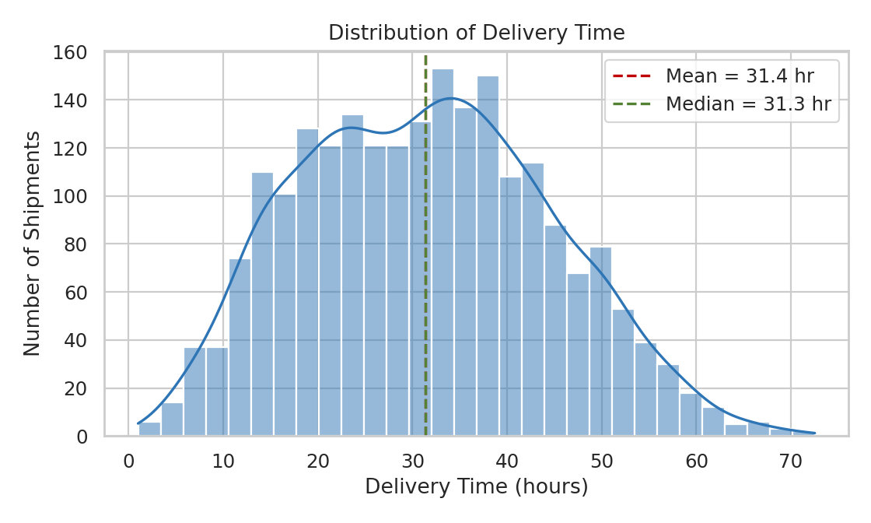
Figure 1. Histogram with KDE overlay showing the distribution of delivery times across all shipments.
A histogram with a kernel density overlay was chosen because delivery time is a continuous variable and the shape of its distribution (symmetric vs. skewed, single-peaked vs. multi-modal) is central to understanding service consistency. The distribution here is broadly bell-shaped with a slight right tail, showing that while most shipments cluster around 25-40 hours, a smaller number take considerably longer — these are the shipments operations should investigate first.

3.2 Transportation Cost by Distribution Center
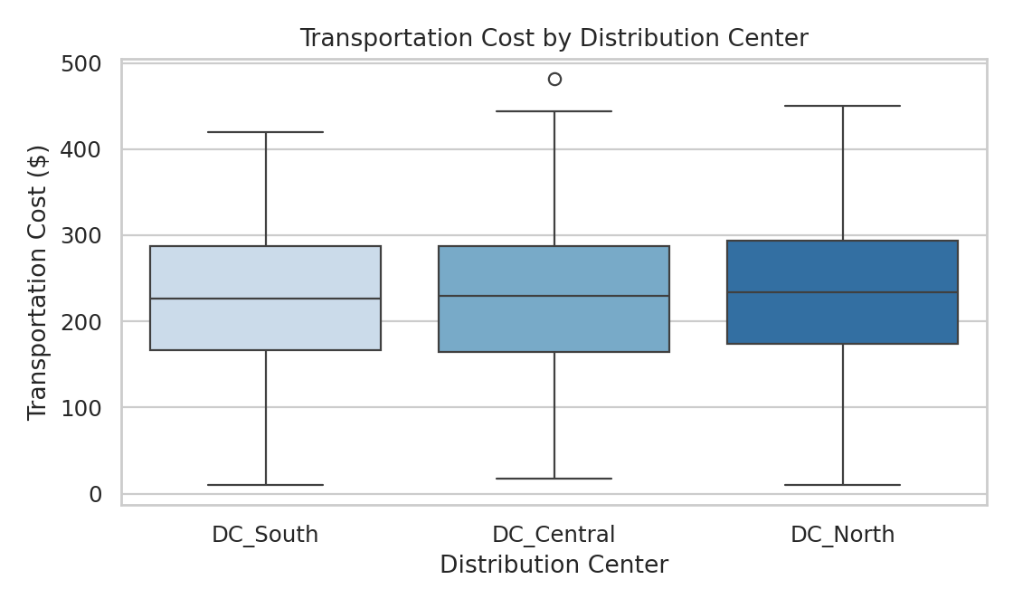
Figure 2. Boxplot comparing the spread of transportation cost across the three distribution centers.
A boxplot was chosen over a simple bar of averages because it also exposes spread and outliers, which matter for cost control. Median transportation cost is broadly similar across all three DCs (roughly $225-235), but DC_Central shows a high-cost outlier above $450, worth a manual review. The similar interquartile ranges suggest no single DC has a systemic cost problem relative to the others.

3.3 Weekly Shipment Volume Trend
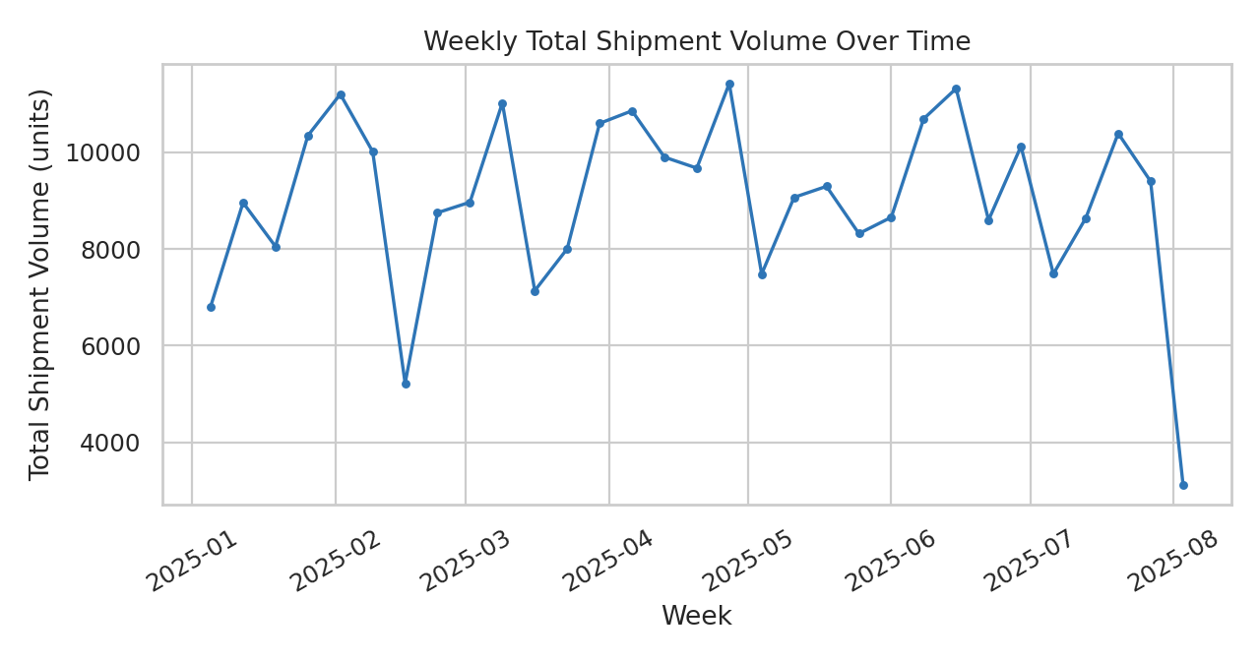
Figure 3. Total shipment volume aggregated by week across the ~7-month observation window.
A line chart is the natural choice for a trend over time. Weekly volume fluctuates without a strong long-term upward or downward trend in this simulated dataset, which is a useful baseline: in a real deployment, this same chart would be the first place to look for seasonality (e.g., holiday spikes) or a growth/decline trend that should feed into the demand forecasting model from Week 1.

3.4 Correlation Matrix of Key Variables
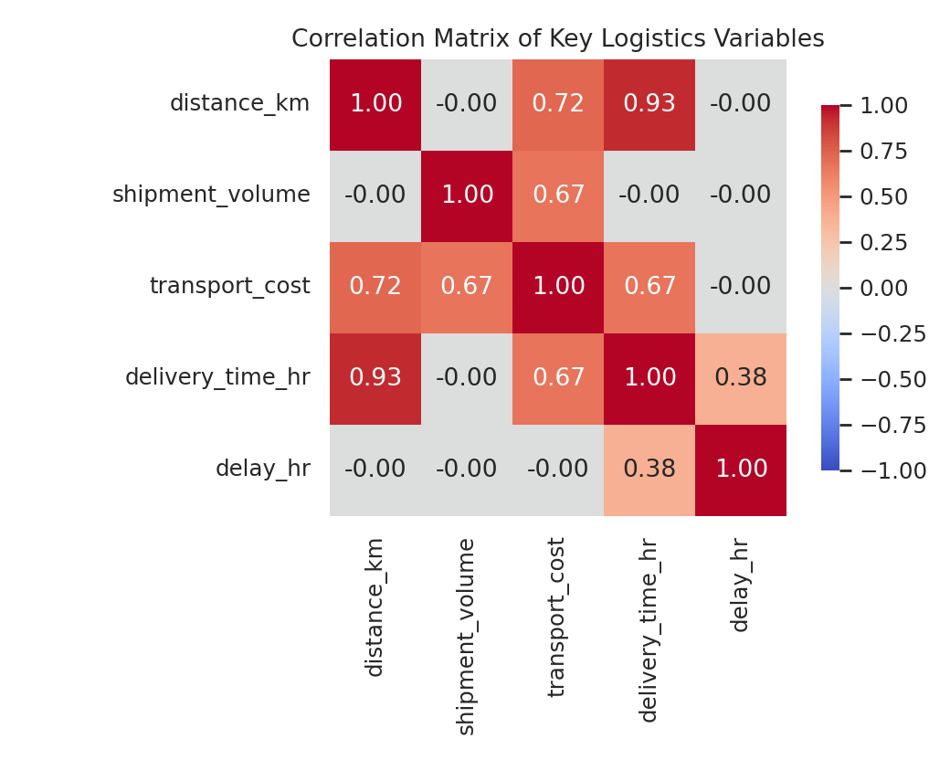
Figure 4. Heatmap of pairwise Pearson correlations between the five core numeric variables.
A heatmap communicates many pairwise relationships at once, which would take five or six separate scatterplots to show individually. Color intensity draws the eye immediately to the strongest relationships (distance-delivery time, distance-cost) without requiring the reader to scan a table of numbers.

3.5 Transportation Cost vs. Distance
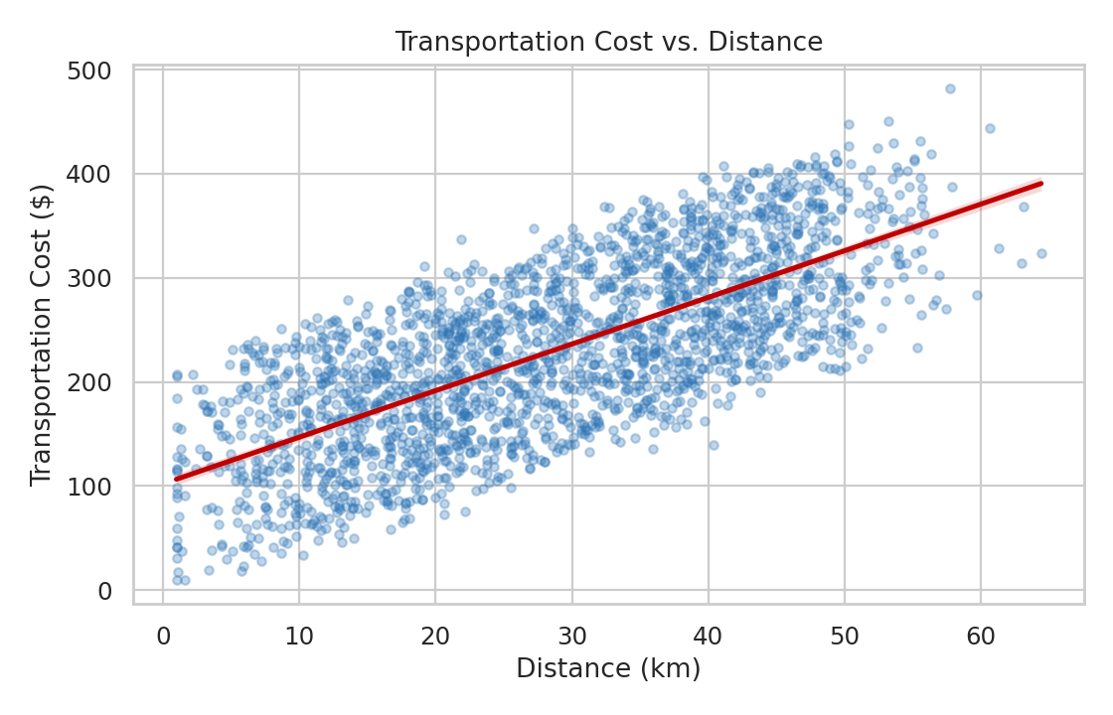
Figure 5. Scatterplot of transportation cost against distance, with a fitted linear trend line.
Having identified distance-cost as one of the strongest relationships in the heatmap, a scatterplot with a fitted trend line was used to examine that specific relationship directly. The upward linear trend confirms cost scales roughly linearly with distance, which supports using distance as a primary input feature in any future cost-prediction model.

3.6 Average Delivery Delay by Region
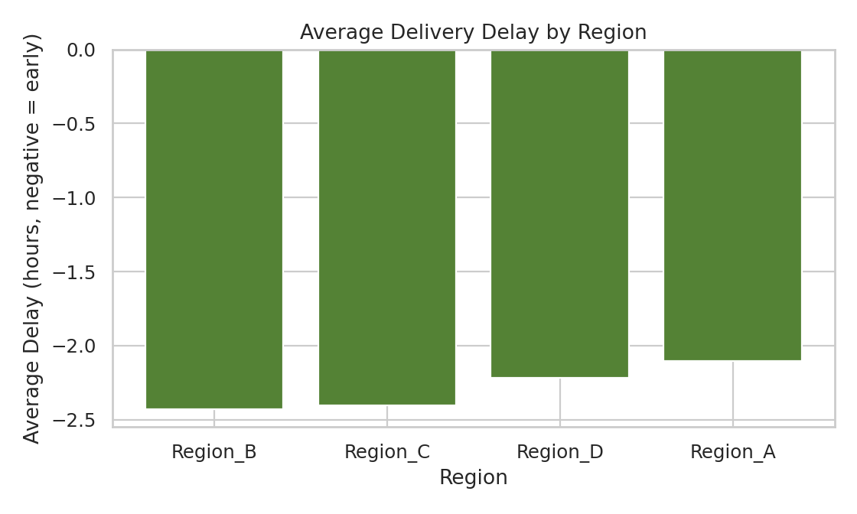
Figure 6. Average delivery delay (hours) by destination region; negative values indicate early delivery.
A bar chart was used here because region is categorical and the comparison of interest is a single summary value (average delay) per category. All four regions show a negative average delay (early delivery) in this dataset, with Region_B slightly ahead of the others — a useful sanity check that no single region is systematically underperforming on promise-time accuracy.

4. Code Documentation
All visualizations were produced with matplotlib and seaborn. The snippets below correspond to each figure in Section 3, operating on a DataFrame df with the columns described in Section 1.

4.1 Setup and Summary Statistics
import pandas as pd
import matplotlib.pyplot as plt
import seaborn as sns

sns.set_theme(style='whitegrid', palette='deep')

summary = df[['distance_km', 'shipment_volume', 'transport_cost',
'delivery_time_hr', 'delay_hr']].describe()
print(summary)

4.2 Figure 1 — Delivery Time Distribution (Histogram + KDE)
plt.figure(figsize=(7, 4.2))
sns.histplot(df['delivery_time_hr'], bins=30, kde=True, color='#2E75B6')
plt.axvline(df['delivery_time_hr'].mean(), color='#C00000', linestyle='--',
label=f"Mean = {df['delivery_time_hr'].mean():.1f} hr")
plt.axvline(df['delivery_time_hr'].median(), color='#548235', linestyle='--',
label=f"Median = {df['delivery_time_hr'].median():.1f} hr")
plt.title('Distribution of Delivery Time')
plt.xlabel('Delivery Time (hours)')
plt.ylabel('Number of Shipments')
plt.legend()
plt.tight_layout()
plt.savefig('delivery_time_distribution.png', dpi=160)

4.3 Figure 2 — Cost by Distribution Center (Boxplot)
plt.figure(figsize=(7, 4.2))
order = df.groupby('dc_id')['transport_cost'].median().sort_values().index
sns.boxplot(data=df, x='dc_id', y='transport_cost', order=order)
plt.title('Transportation Cost by Distribution Center')
plt.xlabel('Distribution Center')
plt.ylabel('Transportation Cost ($)')
plt.tight_layout()
plt.savefig('cost_by_dc_boxplot.png', dpi=160)

4.4 Figure 3 — Weekly Shipment Volume Trend (Line Chart)
weekly = df.set_index('order_date').resample('W')['shipment_volume'].sum()

plt.figure(figsize=(8, 4.2))
plt.plot(weekly.index, weekly.values, marker='o', markersize=3)
plt.title('Weekly Total Shipment Volume Over Time')
plt.xlabel('Week')
plt.ylabel('Total Shipment Volume (units)')
plt.xticks(rotation=30)
plt.tight_layout()
plt.savefig('weekly_volume_trend.png', dpi=160)

4.5 Figure 4 — Correlation Heatmap
corr = df[['distance_km', 'shipment_volume', 'transport_cost',
'delivery_time_hr', 'delay_hr']].corr()

plt.figure(figsize=(6.5, 5.2))
sns.heatmap(corr, annot=True, fmt='.2f', cmap='coolwarm',
vmin=-1, vmax=1, square=True, cbar_kws={'shrink': 0.8})
plt.title('Correlation Matrix of Key Logistics Variables')
plt.tight_layout()
plt.savefig('correlation_heatmap.png', dpi=160)

4.6 Figure 5 — Distance vs. Cost (Scatter + Regression Line)
plt.figure(figsize=(7, 4.5))
sns.regplot(data=df, x='distance_km', y='transport_cost',
scatter_kws={'alpha': 0.3, 's': 15}, line_kws={'color': '#C00000'})
plt.title('Transportation Cost vs. Distance')
plt.xlabel('Distance (km)')
plt.ylabel('Transportation Cost ($)')
plt.tight_layout()
plt.savefig('distance_vs_cost_scatter.png', dpi=160)

4.7 Figure 6 — Average Delay by Region (Bar Chart)
region_delay = df.groupby('region')['delay_hr'].mean().sort_values()
colors = ['#548235' if v <= 0 else '#C00000' for v in region_delay.values]

plt.figure(figsize=(7, 4.2))
plt.bar(region_delay.index, region_delay.values, color=colors)
plt.axhline(0, color='black', linewidth=0.8)
plt.title('Average Delivery Delay by Region')
plt.xlabel('Region')
plt.ylabel('Average Delay (hours, negative = early)')
plt.tight_layout()
plt.savefig('avg_delay_by_region.png', dpi=160)

5. Analytical Insights
- Distance is the primary cost and time driver: with correlations of 0.93 (time) and 0.72 (cost), distance explains most of the variation in both delivery time and transportation cost. Route optimization efforts (as planned in Week 1) will have the largest impact on cost and speed if they focus on reducing effective travel distance, e.g., through better zone-based routing.
- DC_Central carries the greatest cost-outlier risk: while median cost is similar across all three DCs, DC_Central's boxplot shows a high-cost outlier shipment worth investigating — possibly a special/expedited shipment or a routing inefficiency specific to that DC.
- Delay is not distance-driven: since delay_hr shows almost no correlation with distance_km, chronically-late shipments are unlikely to be explained simply by "shipments that travel far arrive late." This points toward scheduling, promise-time-setting, or DC-level handling as more likely root causes than route length itself, and is where root-cause investigation should be focused next.
- The network is not currently in an on-time-delivery crisis, on average: average delay is negative across every region, meaning shipments arrive earlier than promised on average network-wide. This is a positive operational signal but also suggests promised delivery windows may have room to be tightened, which could be used competitively (faster promised times) without increasing actual late-delivery risk.
- Weekly volume shows no strong trend or clear seasonality in this window: this establishes a stable baseline; if a real deployment shows volume climbing over time, DC capacity and vehicle fleet planning should be revisited proactively rather than reactively.

6. Recommendations
Based on the findings above, three actions are recommended, each tied directly to a visualization in Section 3: (1) prioritize distance-reduction through zone-based route optimization, since distance is the strongest lever on both cost and time (Figures 4-5); (2) open a manual review of the DC_Central high-cost outlier shipment identified in Figure 2 before assuming it reflects a systemic issue; and (3) investigate delay drivers at the DC/scheduling level rather than the route level, since delay is largely decoupled from distance (Figure 4). Together, these translate the exploratory analysis into concrete next steps for the logistics planning team, continuing directly from the KPI framework and roadmap defined in Week 1.

